**[32] Design Turing Machine For String Comparison W = ABA ABA**

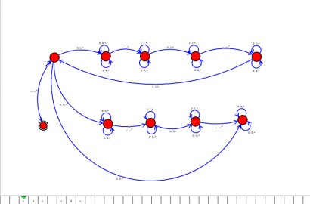

**Result**

The TM is designed to perform string comparison with given strings using AutoSim tool